Zach: finding transitions

* looking for mean and standard deviation not general enough, want to be able to segment recording without any prior knowledge
* ClaSP: designed for periodic waveform within states
  + divide recording into chunks, train model to guess chunks before and after
* Does fairly well with various transition types, generally picks up on changes in state
* Promising, but still need tool to identify waveform types between transitions
* In examples shown, window size is about 1 second

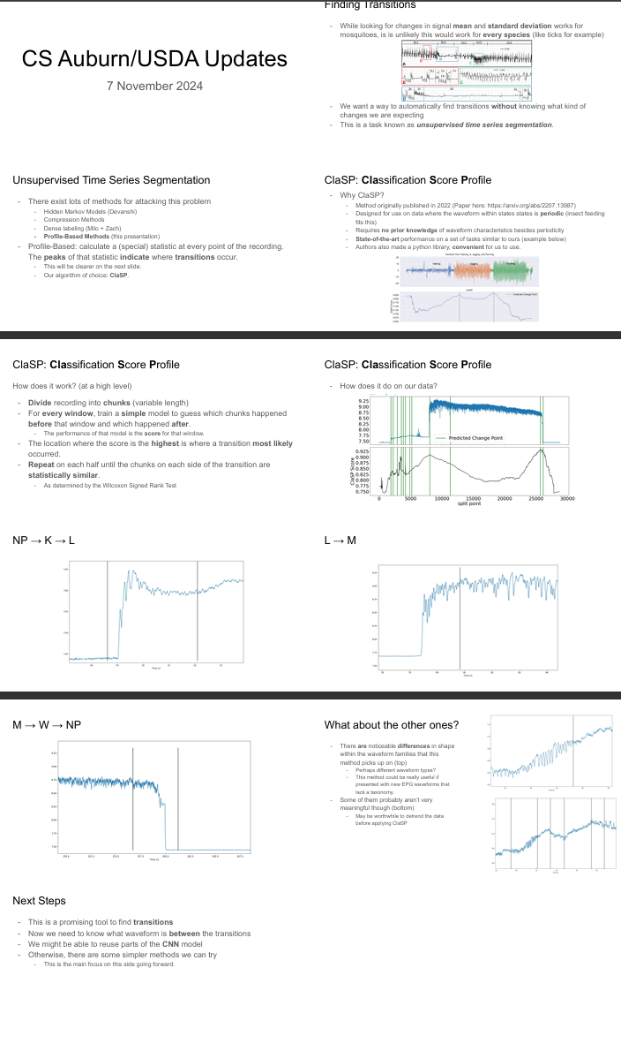

Milo: deep learning update (continued from last meeting)

* precision: return only data points in a class
* recall: identify all data points in a class
* current models are using equal weighting (weight equals number of data points of type)
* Next steps: upweight minority classes, downweight edge points
* Dr. Reif: seems reasonable to downweight the edge points between transitions
* Dr. Cooper: desired accuracies M-N within 3 seconds is reasonable, K-L within 1 second (because K is short)
* Idea of weighting is to penalize model less harshly at places where mistakes are reasonable
* Dr. Cooper: perhaps remove W entirely, weight J and K heaviest because infrequent, weight M and L the lowest because long and in every probe
* Dr. Reif: could have researcher set start and end points in recording when files is first uploaded
* Would it make sense to have the researcher label the start and end of each probe before the model processes the file?
* Zach: this is something we can automate, start and end are fairly easy to identify (applying moving average filter smooths signal)

Dr. Backus: background on W

* In most hemipterans, there’s a spike at the end of a probe and then abrupt down, the pullout spike, due to hardening saliva
* Doesn’t always happen, depends on species and input resistance Ri
* It’s a resistance component, so only seen at certain Ri values
* Was usually incorporated into the last waveform, but more recently identified as W waveform — important to identify because it has biological significance
* Model will eventually need to incorporate this behavior when applied to hemipterans
* Generally only happens in AC recordings

Mehrezat: presentation feedback

* Mixed on whether to go into more or less detail on machine learning
* Also mixed on whether to make it more or less boring

How are things going?

* Dr. Reif: ease of dialogue is good, interactions have been positive
* Dr. Backus: trepidation due to limited CS background, but team has been doing a good job breaking down the work to make it understandable
* Dr. Cooper: seems like team is making good progress
  + Aedes aegypti data: team should check whether existing spreadsheet format is usable
* Dr. Reif: potential for publication based on this work, potential overlap with final report
  + Dr. Backus: if publishing, need to keep in mind IP issues, should talk to patent attorney
* Dr. Backus: team should think about if/when to visit Parlier or Auburn

Note: No meeting next week Thurs 11/14 due to conference.